Ethan Richardson
ethanrichardsonanimate@gmail.com
www.ethanrichardson.com

Breakdown Sheet

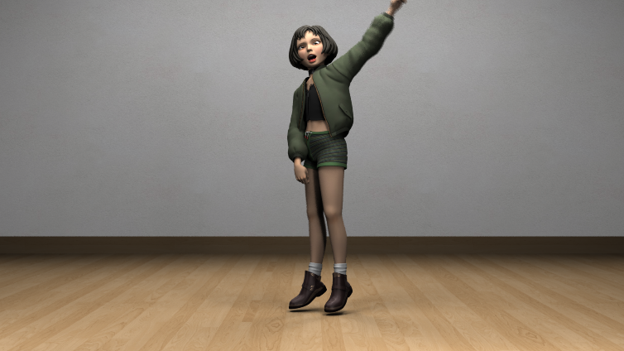 | GFriend – Me Gusta Tu Dance  Program: Maya  Responsibilities: animation, background modeling, background texturing, lighting  Mathilda Rig is developed by Leon Li-Aun Sooi and Xiong Lin from Savannah College of Art and design.
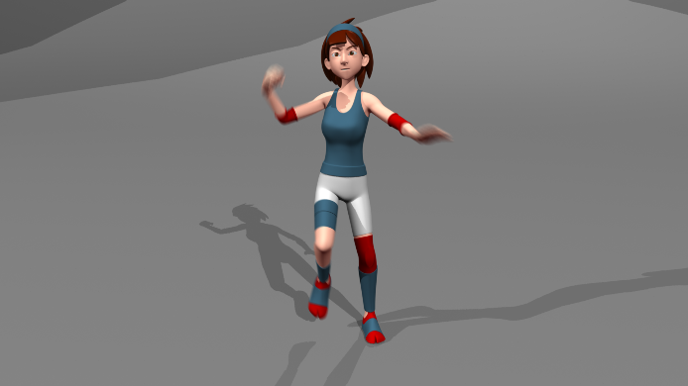 | Martial Arts Animation  Program: Maya  Responsibilities: animation  Model and Rig by On One Animation School
Annika Model

Program: Maya, Photoshop (textures)

Responsibilities: Modeling, texturing,

Rigged using Advanced Skeleton
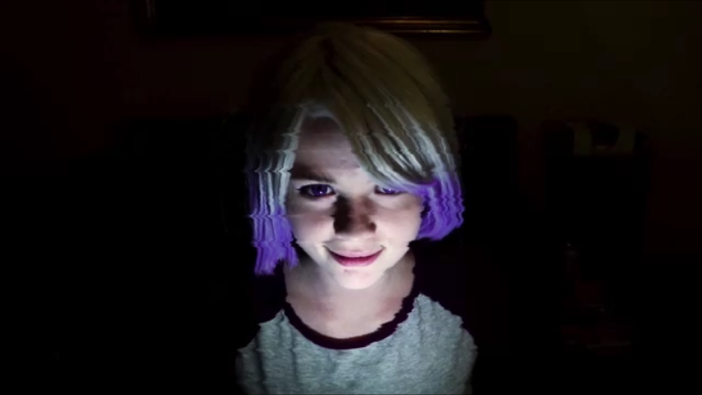 | 3N73R – Short Film  Program: After Effects, Premier Pro  Responsibilities: Everything except sound
Robot

Program: Maya

Responsibilities: Everything

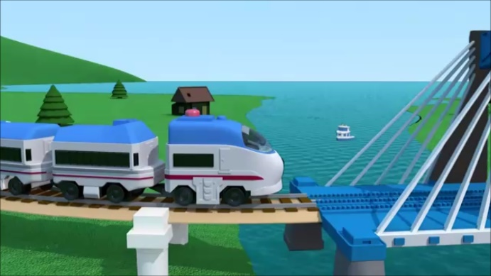 | GeoTrax Project  Program: Maya  Responsibilities: Modeling, texturing, and animating the train and boat; Animation and layout of the track, Camera animation, Editing.
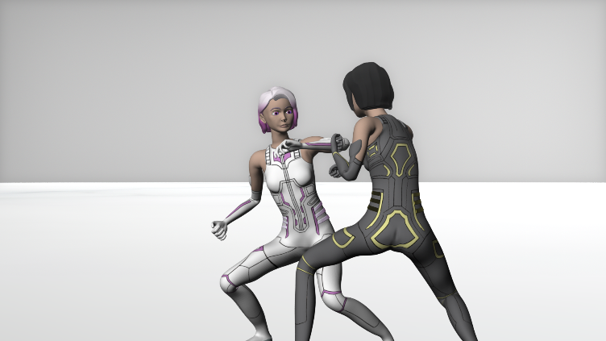 | 3N73R - Short Film  Program: Maya  Responsibilities: Everything except sound  Rigged using Advance Skeleton
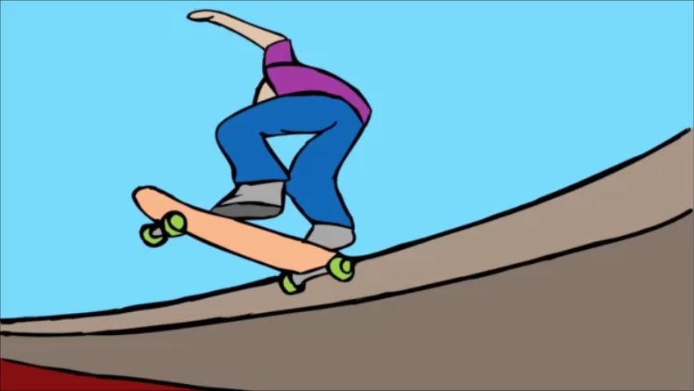 | Skateboard Animation  Program: ToonBoom  Responsibilities: Everything
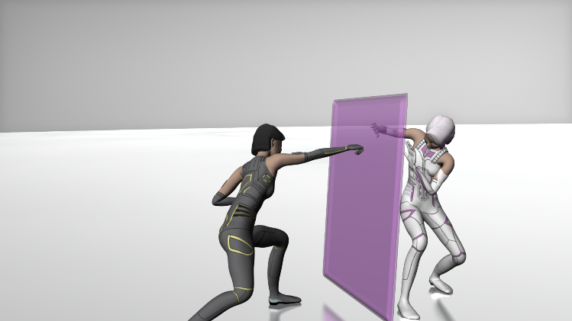 | 3N73R - Short Film  Program: Maya  Responsibilities: Everything except sound  Rigged using Advance Skeleton

